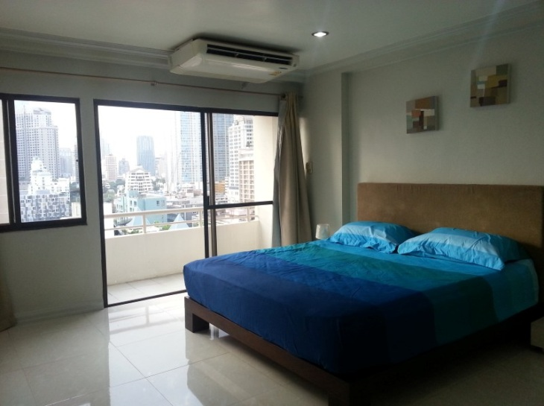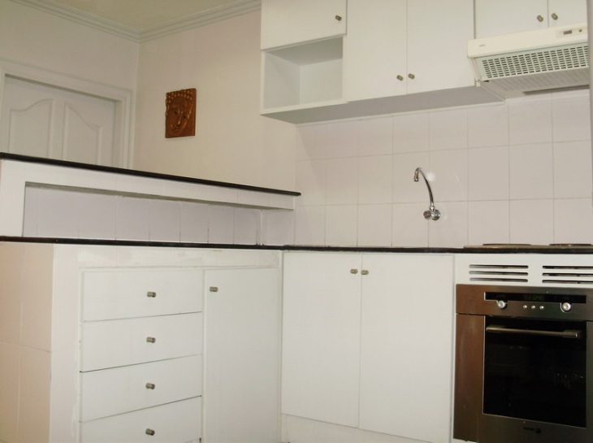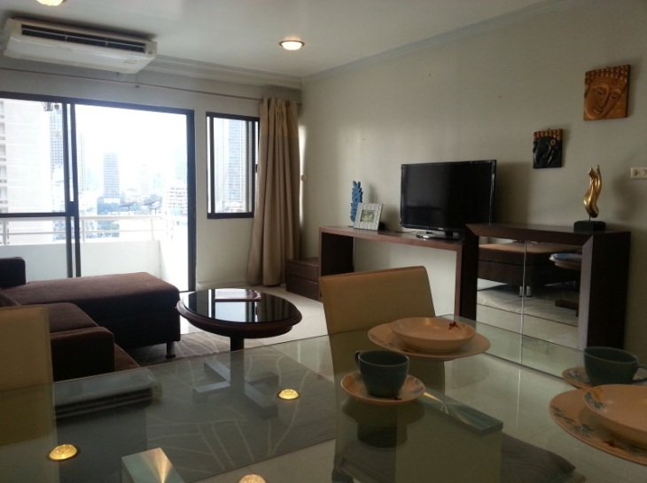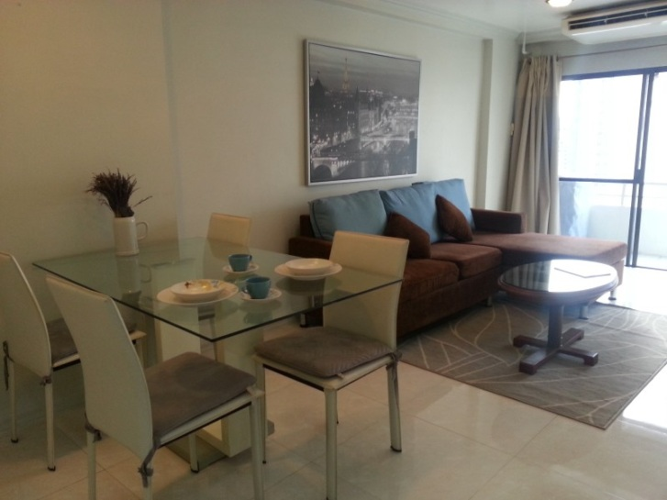

**Condominium 70 sqm. Level 15,1 Bed Rooms.**

**Sukhumvit Soi 6, Nana. New Decorate**

**Swimming Pool. Fitness.**

**Walk to BTS Nana Station.**

**Include : Furniture,**

**Air-condition, TV, Refrigerator.**

**27,000 Baht/Month**

Call : 089-815-0223

